Retail Pricing Management

Author:
Karipe Sai Pravalika
Senior Full Stack Developer

Contents
Retail Pricing Management 1
Case Study Description: 3
Functional Requirements: 3
Non-Functional Requirements: 3
Framework/Technologies Used: 3
Frontend: 3
Backend: 3
Database: 3
Context Diagram: 4
Architecture Diagram 4
Design Decisions 5
Functional/Performance Design: 5
Data Design: 6
NFR Decisions 6
Assumptions 7
Code Source 7
Database Design (ER Diagram) 7
UI Screen Artifacts 8
Store Selection 8
Pricing Management 9
Future Scope 11

Case Study Description:

Functional Requirements:
Create a Web application with the below details,
- Build upload features that take pricing data from CSV files and save it into database tables for future use.
- Implement functionality where users can search pricing records using filters and edit / save updates to those pricing records in the database.

Non-Functional Requirements:
Assuming a retail chain with 3000 stores across multiple countries, needs to handle all aspects of NFR and the details are clarified in NFR Design section.

Framework/Technologies Used:

Frontend:
- Angular Version 17
- Angular Material Library (Tables, buttons, popups, hovers, dropdown, inputs)

Backend:
- Python Version 3.11.0
- Fast API with SQL Alchemy (For Async DB Connection)

Database:
- MySQL – Created Local Instance with New Schema and tables required for case study.

Context Diagram:
The context diagram provides a high-level view of Retail Pricing Management and its interaction with entities like User, database, and Pricing Engine. It shows how data flows between system and Users.
The following diagram illustrates the same.
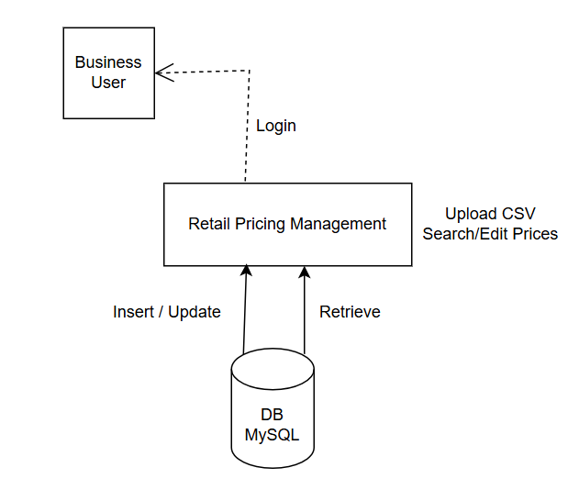

Architecture Diagram
The architecture follows a layered design consisting of:
- Presentation Layer – Web interface used by business users to interact with the system.
- Application Layer – Backend API responsible for handling business logic, processing CSV uploads, and managing pricing data. (Fast API)
- Data Access Layer – Manages communication between the application and the database. (SQL Alchemy in this case)
- Database Layer – MySQL database used to store product, pricing, and store information.
The following diagram illustrates the overall system architecture and interaction between different components.
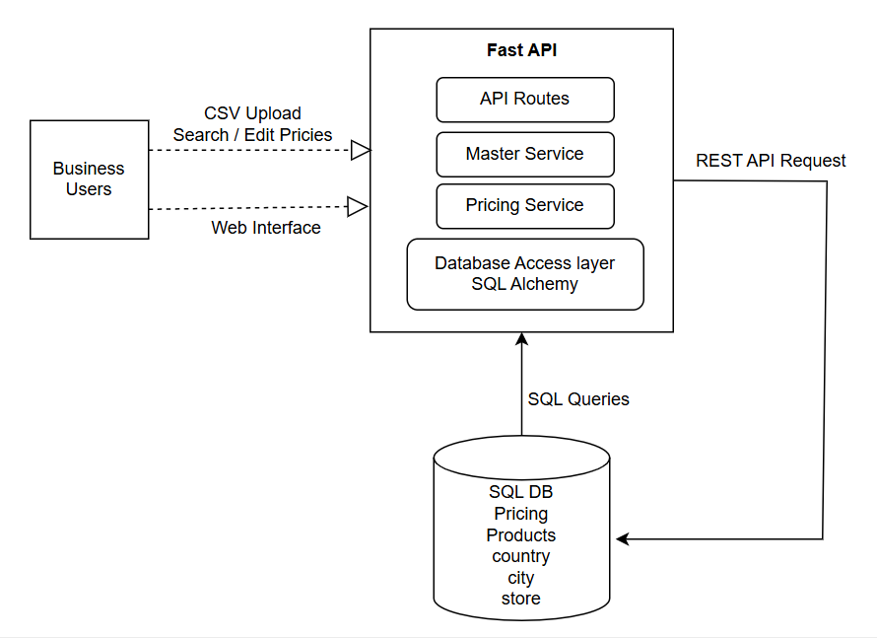

Design Decisions
Considering Functional and Non-Functional requirements, retail store chain with huge stores across multiple locations below are the list of Functional, Data and Performance Design decisions,

Functional/Performance Design:
- User selects, Country -> City -> Store combination on application load and then navigates to Pricing management screen to manage performance of the application.
- Pagination, filtering logic is implemented on server side.
- Pricing History will be shown for last 3 months.
Contributes to Performance Optimization.

Data Design:
- Latest active price will be displayed to the user on pricing management screen for unique Product.
- As sku is unique, upload CSV contains sku column which will fetch product_id internally.
Below is the Core data design and Database Versioning Strategy followed,
- Conditions considered while inserting / Edit of pricing details,
  - Insert new record.
    - When product_id, store_id combination is absent in pricing table.
    - When product_id, store_id combination is present, but effective_date is different, then add new record with all details and is_active to True.
  - Edit existing record.
    - When product_id, store_id and effective_date are same.
    - When product_id, store_id combination is present, but effective_date is different, then update is_active to false.

NFR Decisions
- Performance
  - Server-side Pagination and filter logic implementation
  - Usage of ‘trackBy’ for all ‘*ngFor’ Directive
  - API response time < 2 seconds
  - CSV upload of 10k records < 10 seconds
  - Proper Indexing in DB
- Scalability
  - Database supports horizontal scaling.
- Security
  - Login Authentication (JWT)
  - Input Validation (Pydantic Model)
- Data Integrity
  - No Duplicate pricing records
  - Backend code has unique constraints.
- Audit
  - Tables created have audit columns and system logs data (created_by, updated_by, created_timestamp, update_timstamp)
- Usability
  - User and Enterprise application friendly UX design
  - Easy search and edit functionalities.
- Maintainability
  - Code follows Modular (UI) / layer (Backend) Structure
  - Proper Readme files/documentation

Assumptions
- Individual store pricing management will be managed independently. (To improve performance)
- Uploaded csv should have columns sku, price, effective_date else uploading pricing details into database tables will not be effective.
- Sku value should already be present in ‘product’ table. New sku value cannot be included in uploaded csv.

Code Source
https://github.com/Pravalika-Karipe-1403/retail-pricing-system

Database Design (ER Diagram)
The Entity Relationship (ER) Diagram illustrates the structure of the database, including entities, their attributes, and the relationships between them.
The system primarily consists of entities such as Country, City, Store, Product, and Pricing. Each entity represents a real-world object and stores relevant information required for managing product pricing across multiple store locations.
The following ER Diagram provides a visual representation of the database schema and relationships between different entities.
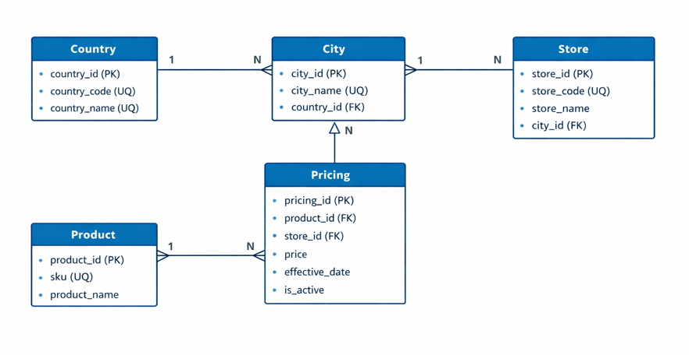

UI Screen Artifacts

Store Selection
User selects country, city and store details from dropdowns, below is the screen for reference,
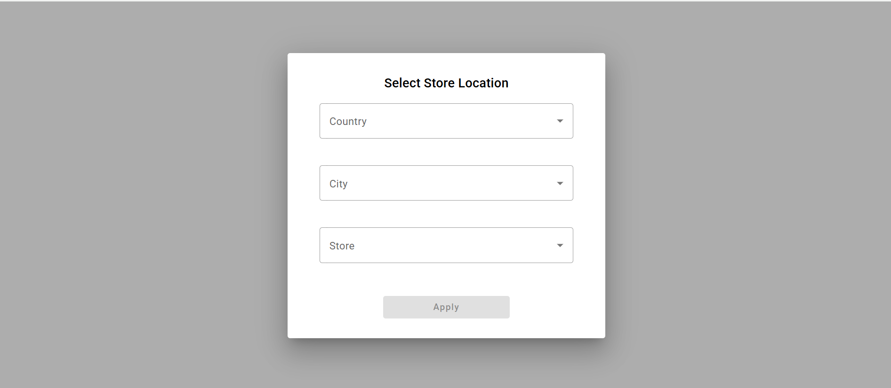

After selecting the details, ‘Apply’ button will be enabled, image for reference,
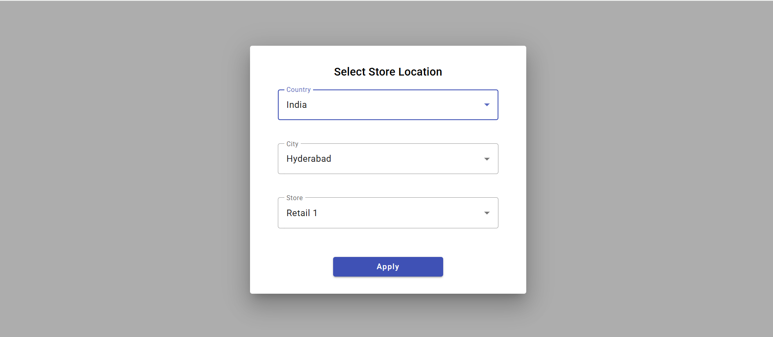

Pricing Management
When user clicks on Apply, User lands on pricing management screen.
Features:
- View latest price.
- Upload CSV
- Edit price/effective_date.
- Pagination
- Filtering
- Price History
Below is the screen for reference,
Retail Pricing Management Screen,
- User selected, Country-City-Store details from popup will be displayed on Retail Pricing Management screen.
- Users can search the data using product filter.
- ‘Change Store’ button will show the Store selection popup to change the Store.
- Upload CSV will update the pricing details against the store_id.
- Editable columns are mentioned with an info icon to notify the users.
- ‘Price History’ under Action column will display last 3 months data against a particular product.
- Inline edit for Price, effective date columns is available, and Bulk save is used to save the data to database tables.
- User edited columns will be highlighted for acknowledgment.
- ‘Save All Changes’ button saves all the data modified by the user in a single go.
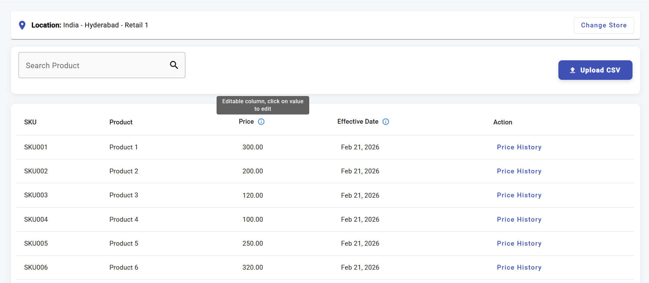

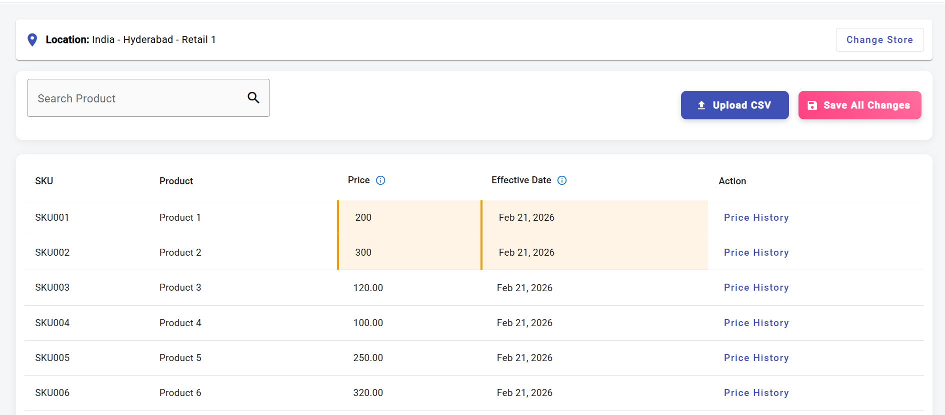
Price History screen,
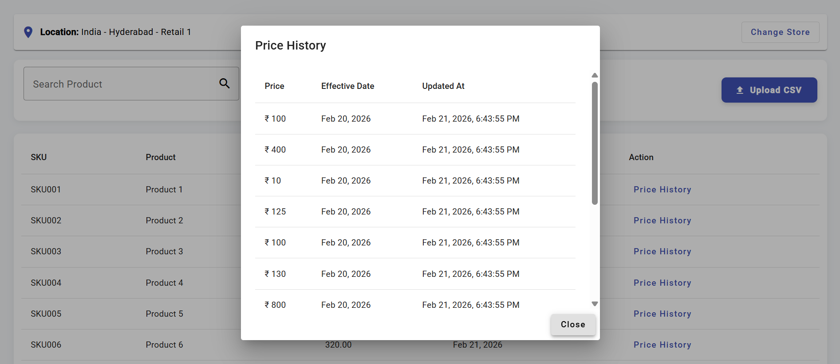
Upload CSV Screen,
- File upload limitation to upload only .csv extension.

Future Scope
- Implementation of Authentication (JWT Token, MSAL) and Authorization (Role-based)
- Unit testing using jest/karma, Jasmin
- Integration testing using Cypress.
- Screen to add New Store, which can in turn have a new Country City combination.
- Audit Screens can be developed.
- Retail pricing Management applications can be used in billing applications where it can be like master data.
- Can implement ML model and suggest the prices for each SKU based on competitors from nearest location and the store manager will have an option to Accept or Decline the suggestion.

